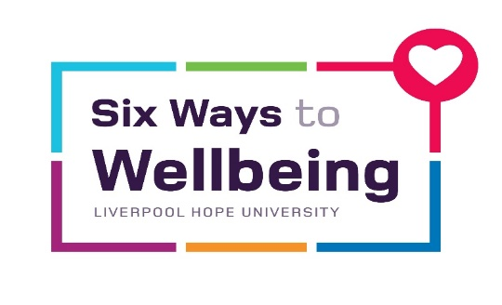
“Craft and Chat”
Thursdays at 12noon

Linking in with the Keep Learning and Connect strands of our “Six Ways to Wellbeing”, our staff “Craft and Chat” Group takes place every Thursday at 12 noon in EDEN 107.
This lunchtime group aims to get staff away from their desks, helps develop their creativity and provides the opportunity to meet up and have a “natter” with colleagues.
From knitting and crochet to sewing and cross-stitch – or anything else that takes your fancy! So come along, learn some new skills and meet some new people.
If you are interested in joining this group or want more information, email Theresa Lewin at lewint@hope.ac.uk

